**ENSF-381**: **Full Stack Web Development Laboratory**

**Lab02**

**Section: Group 6**

**Group information:**

Unas Khalid (30141707)

David Onofeghara (30214188)

**GitHub Link:**

<https://github.com/ovie-d/ENSF-381>

**Exercise 1 Output Screenshot:**

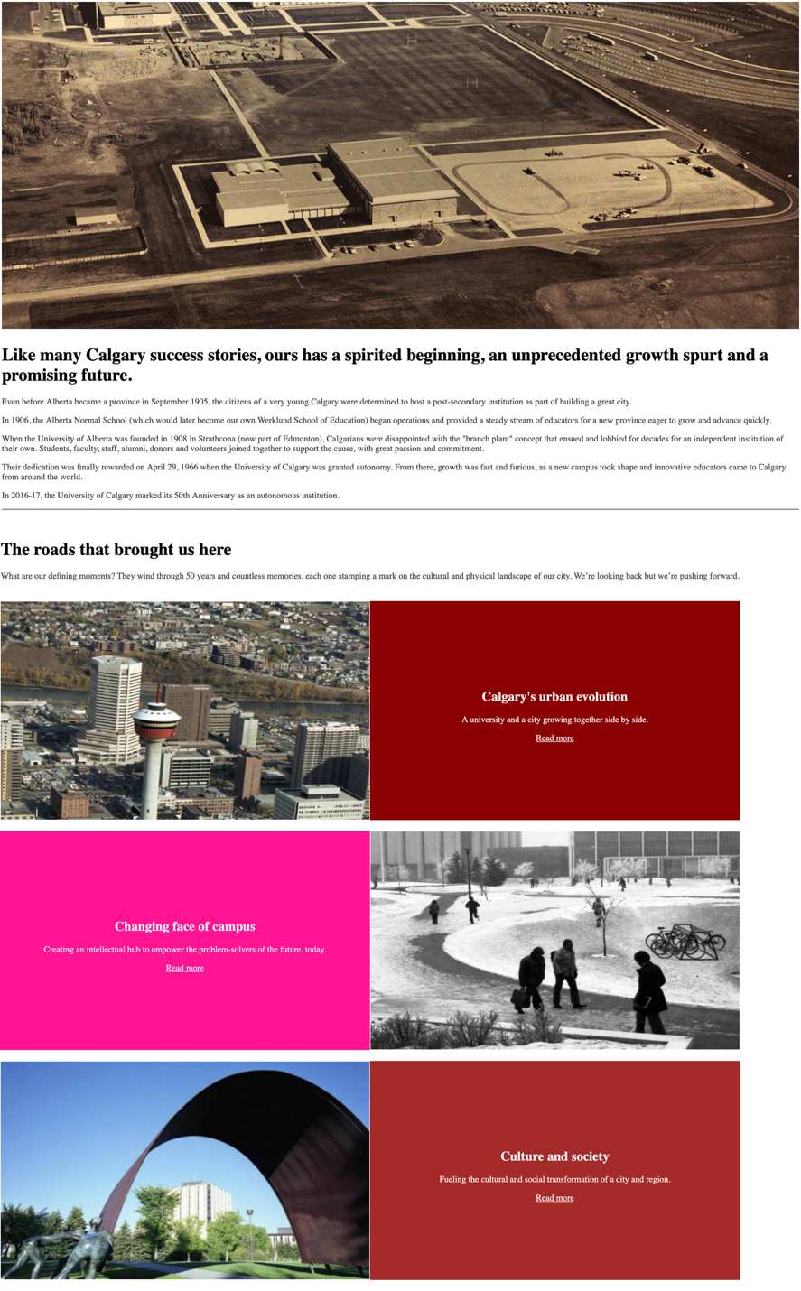

**Exercise 2 Output:**

Screenshot from step 6:

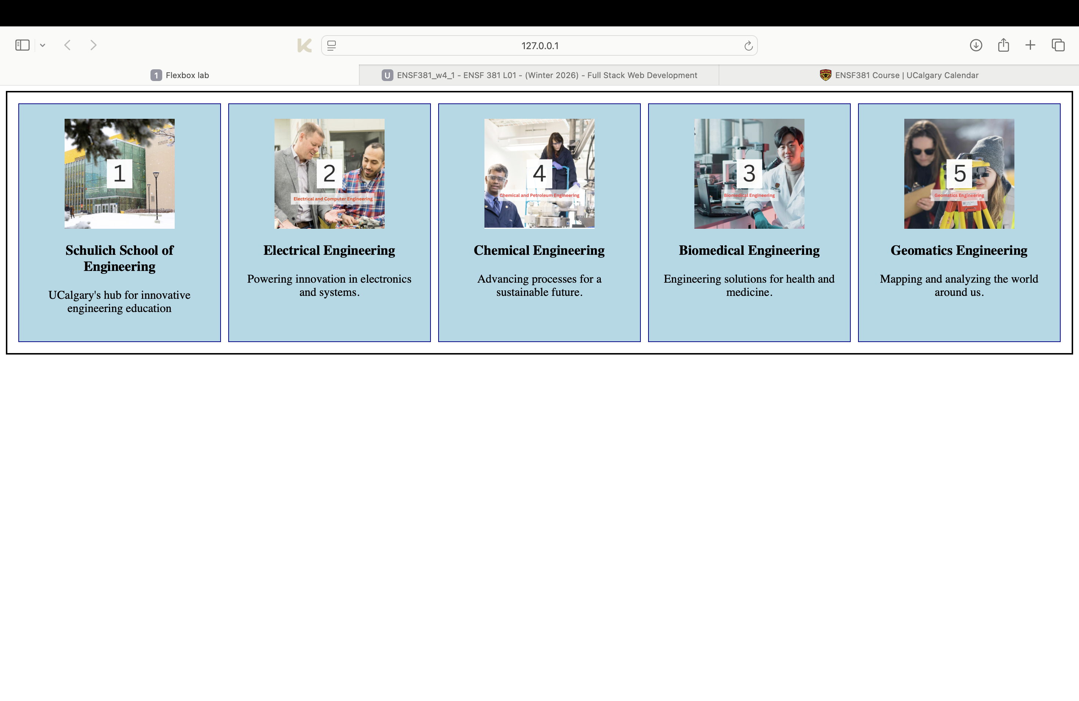

**S**creenshot from step 8:

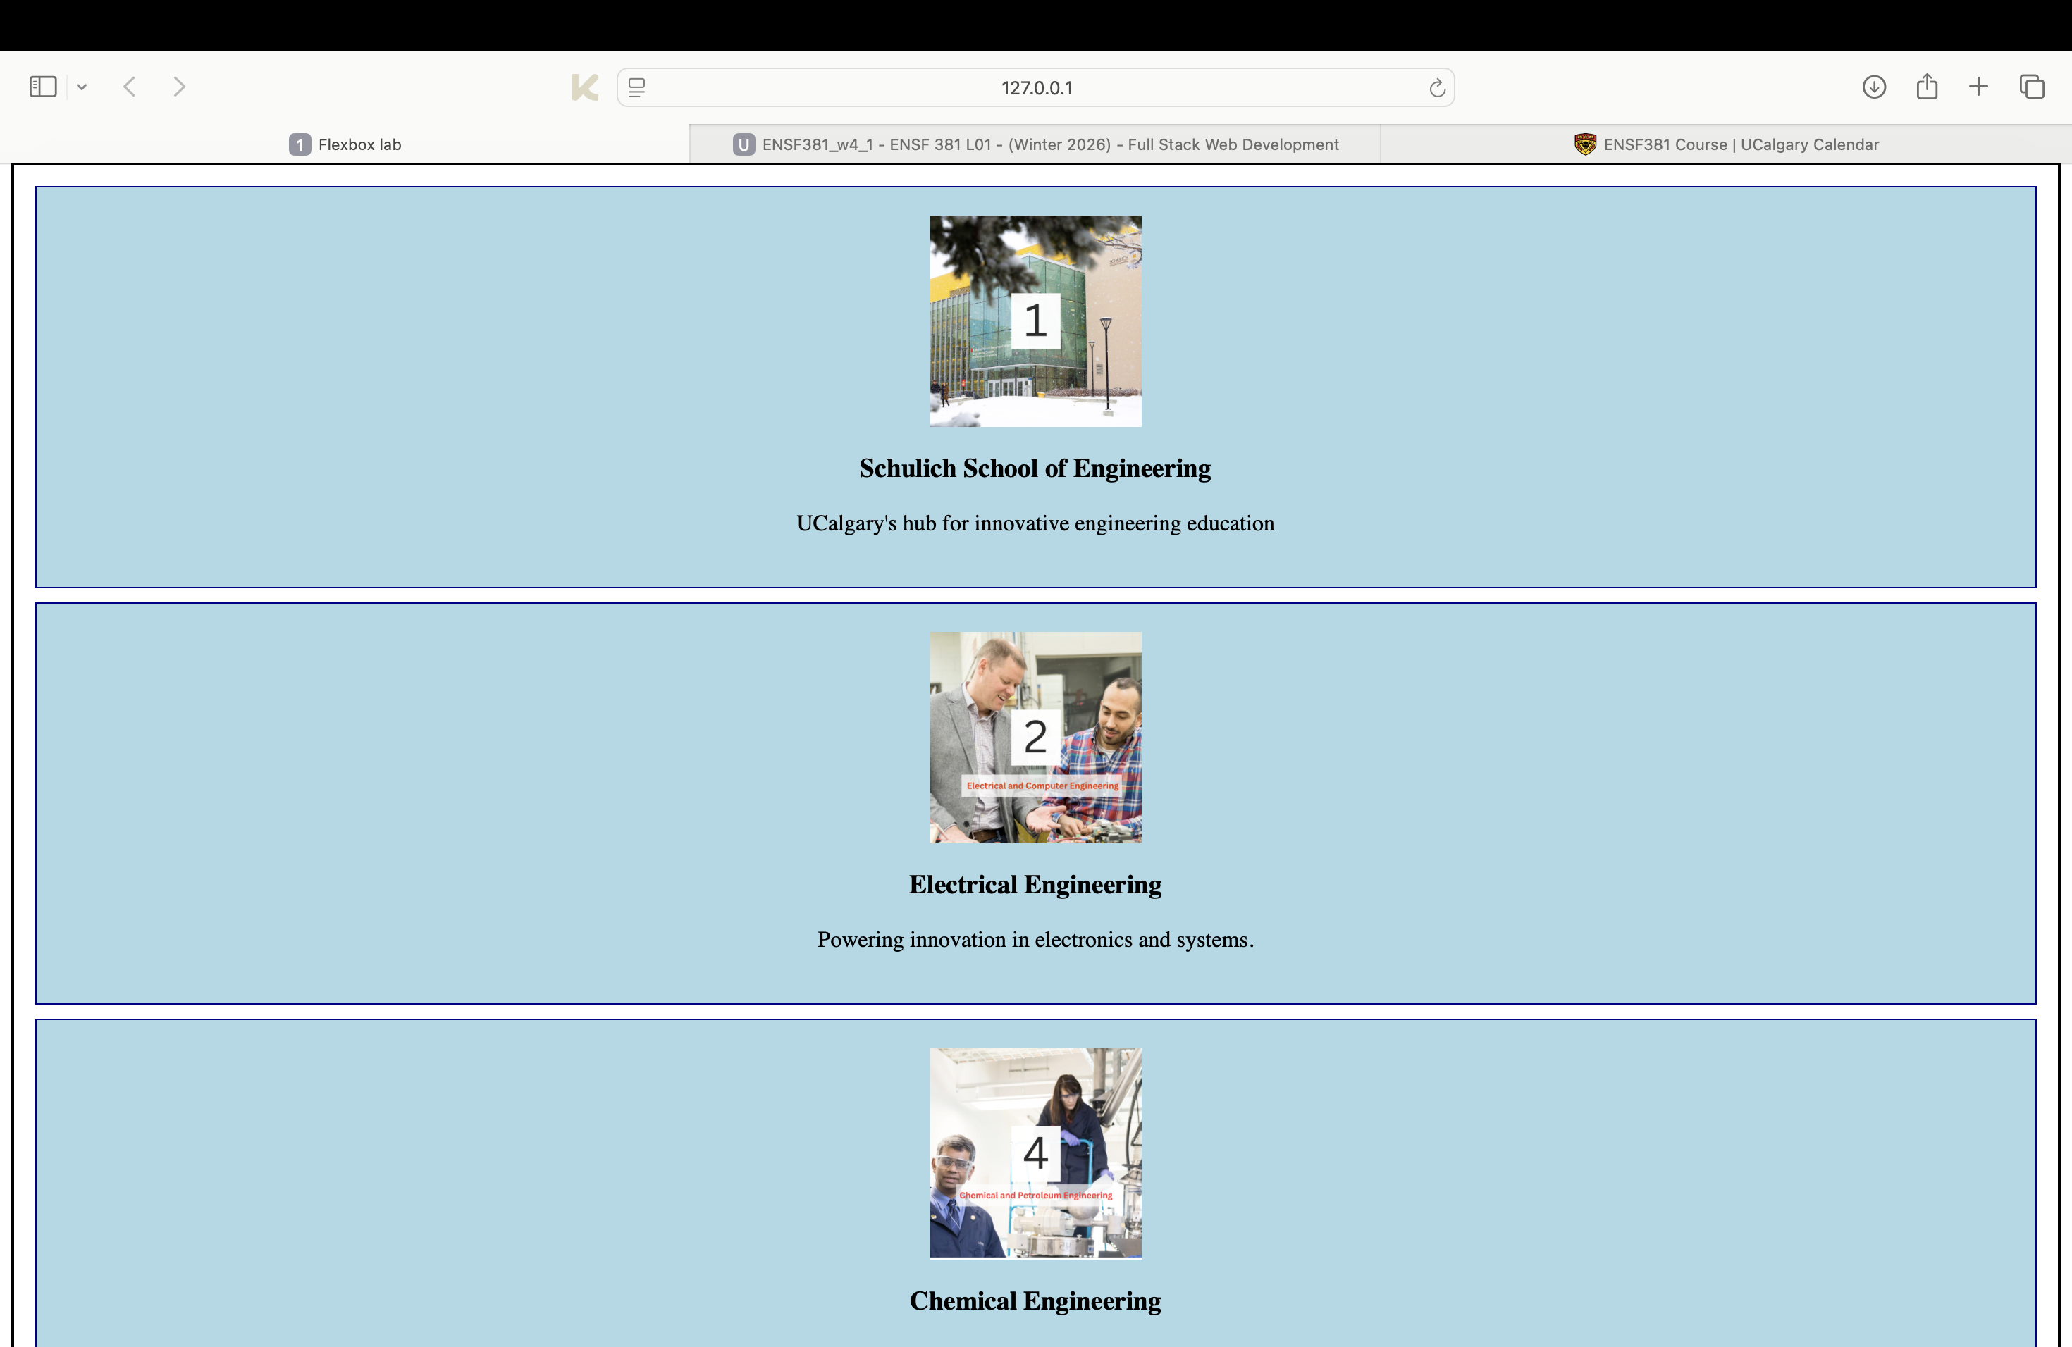

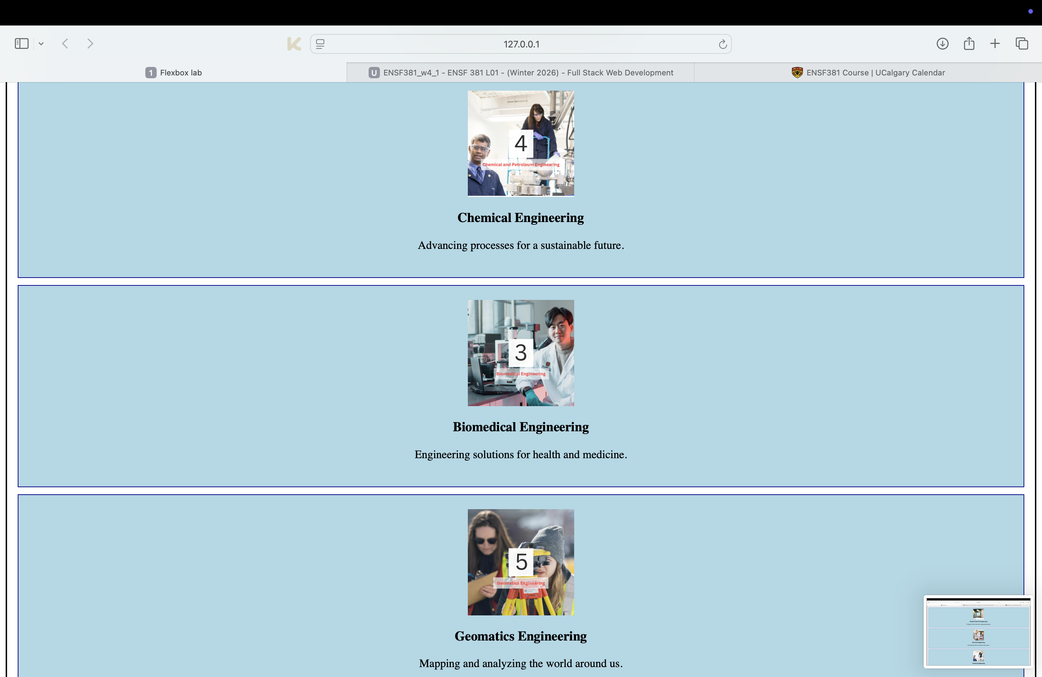

**Two** Screenshots from step 9:

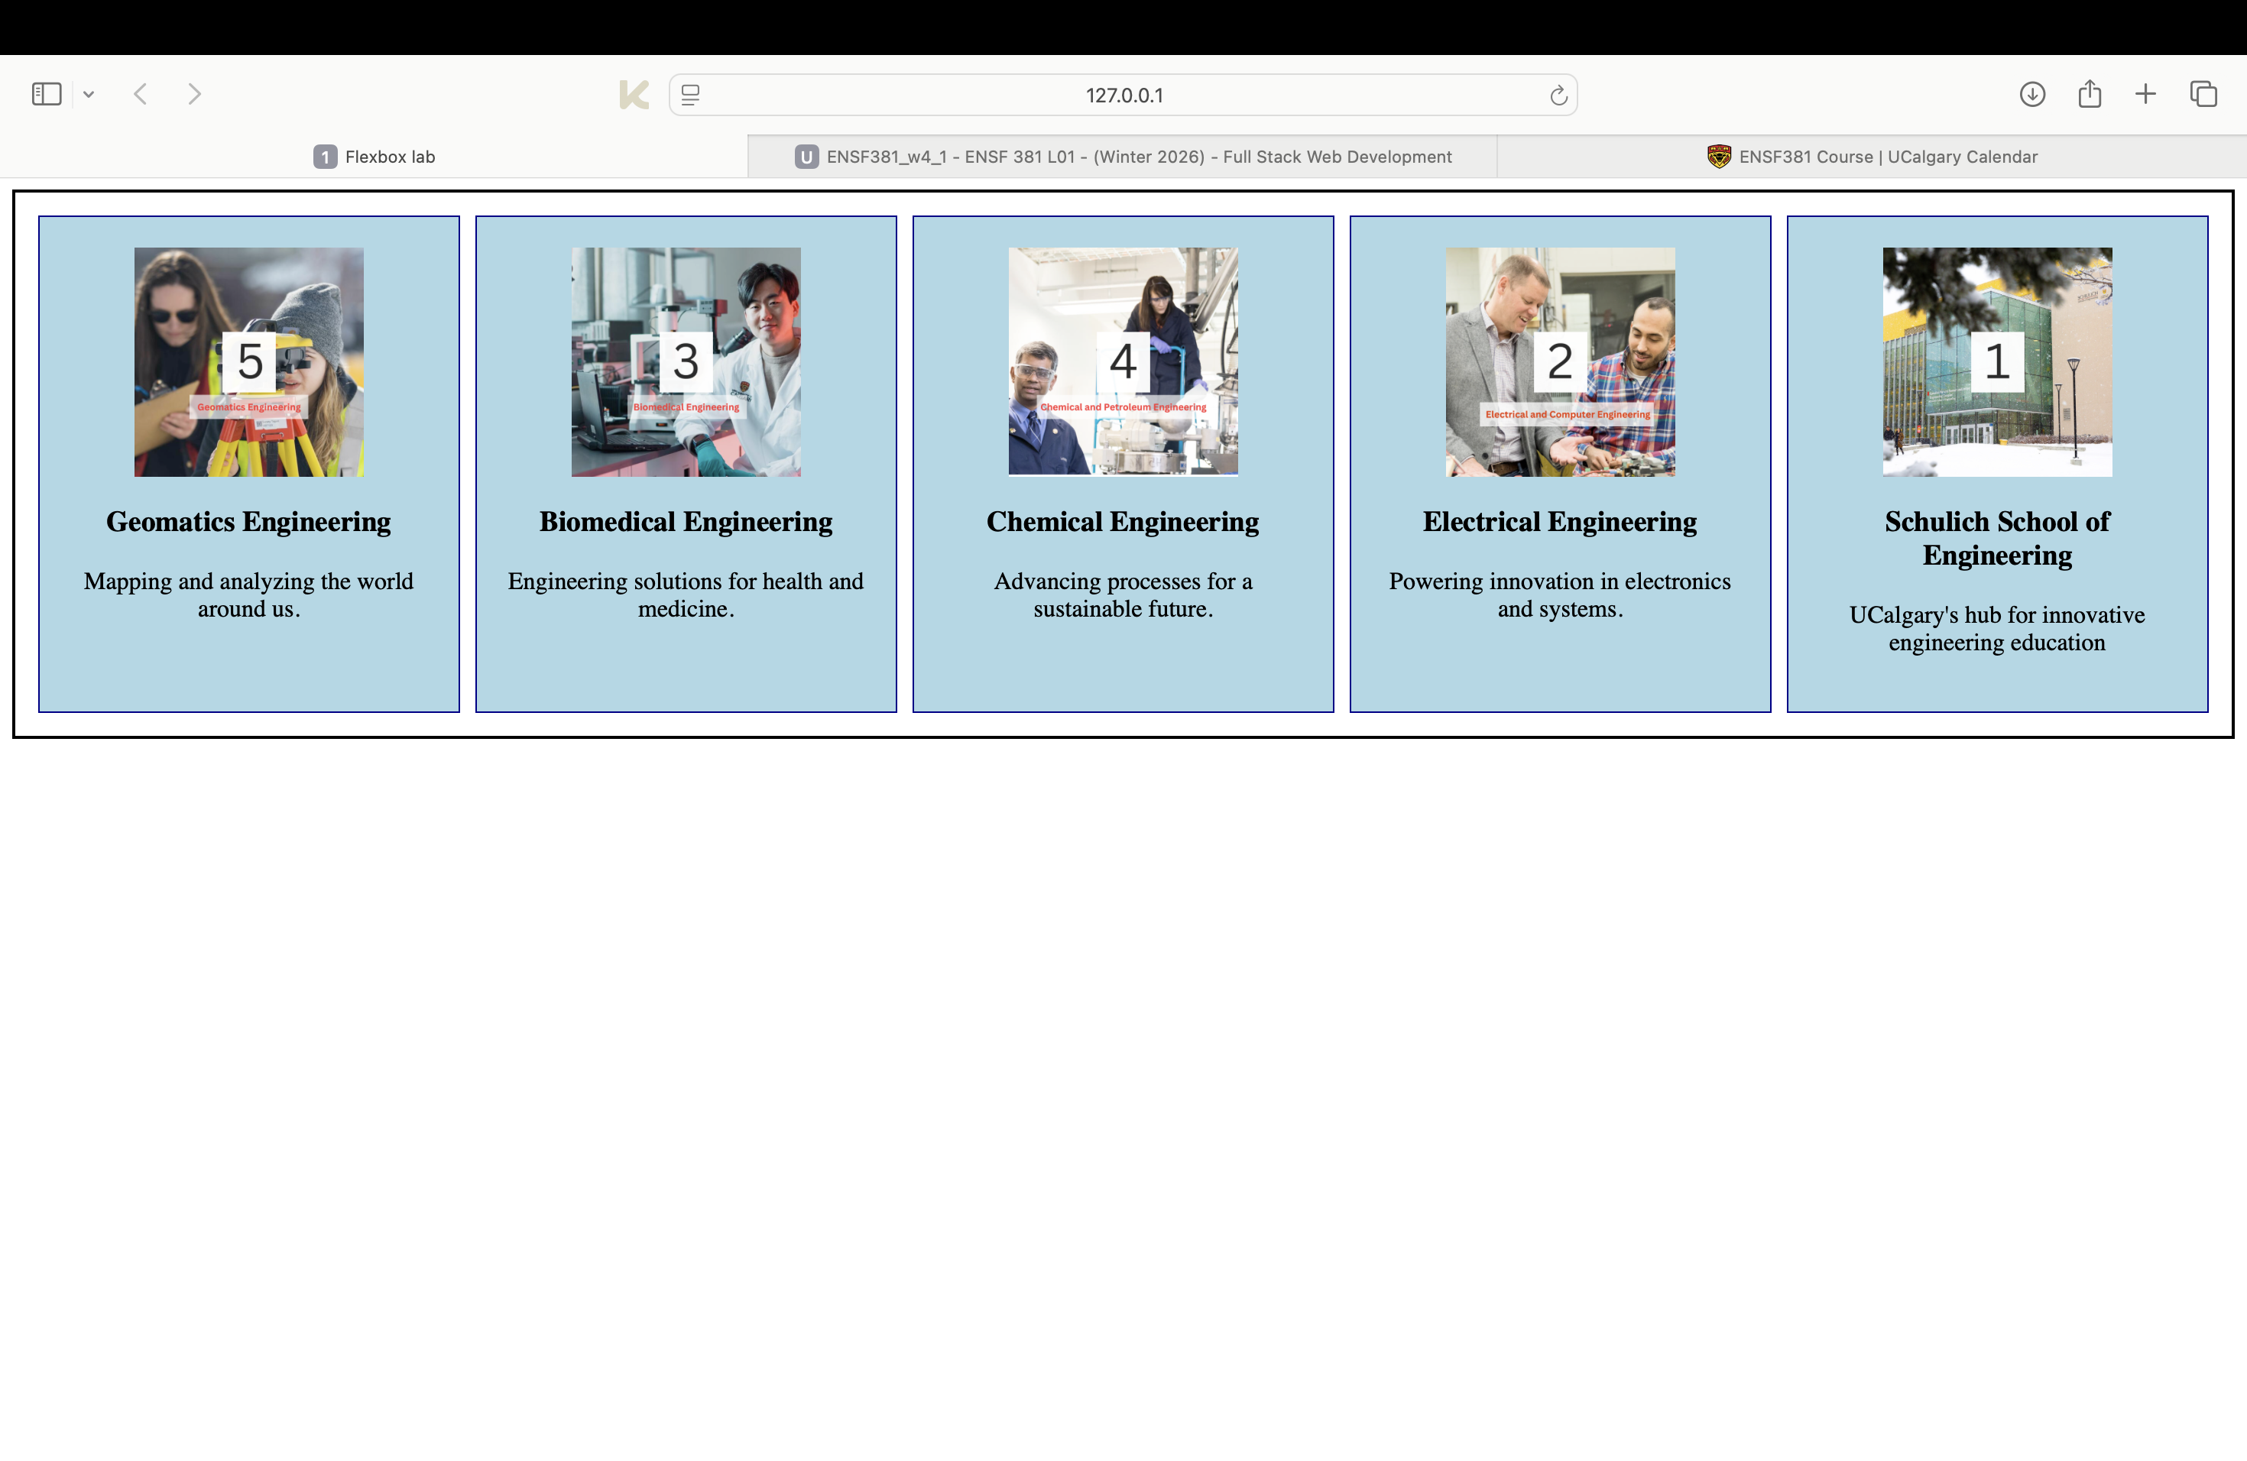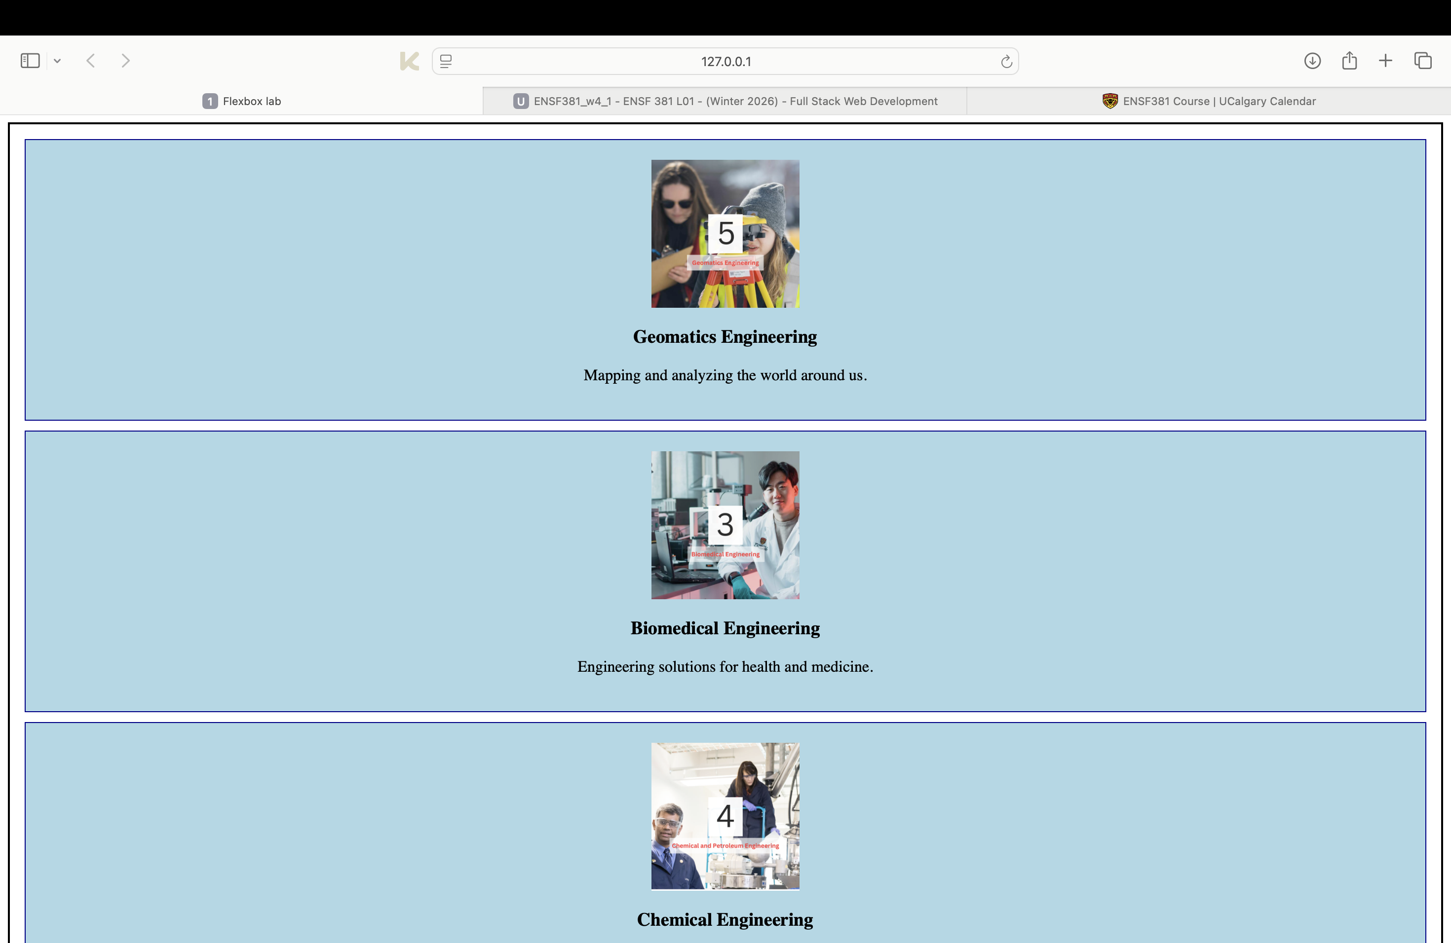

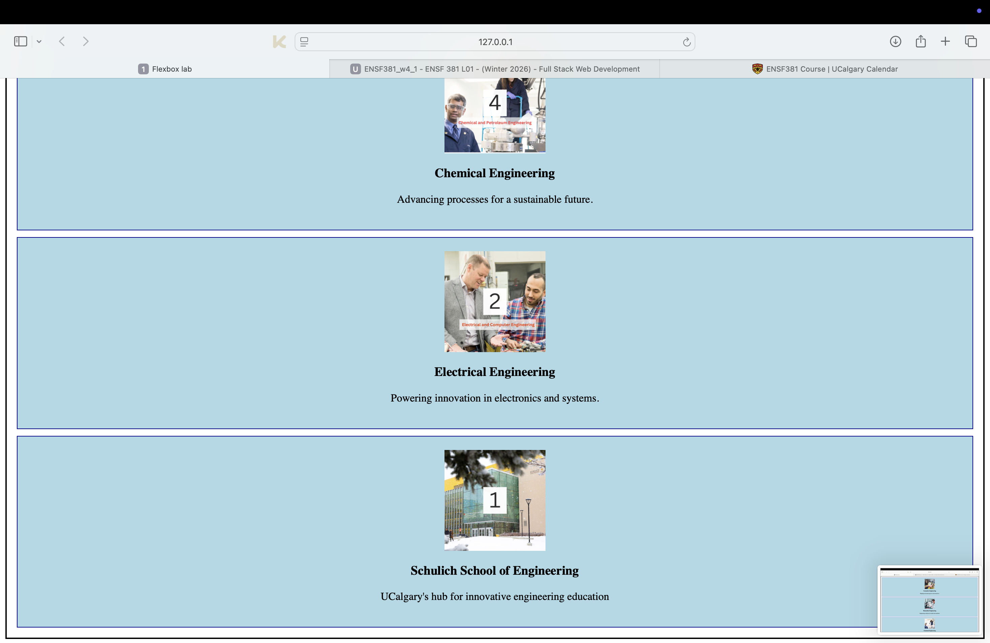

Screenshot from step 12:

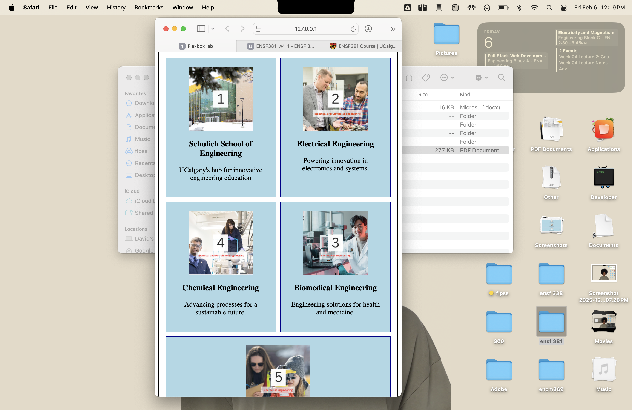

When the browser window is resized to its minimum width, the flex container wraps its child elements onto new lines due to flex-wrap: wrap

Screenshot from step 14:

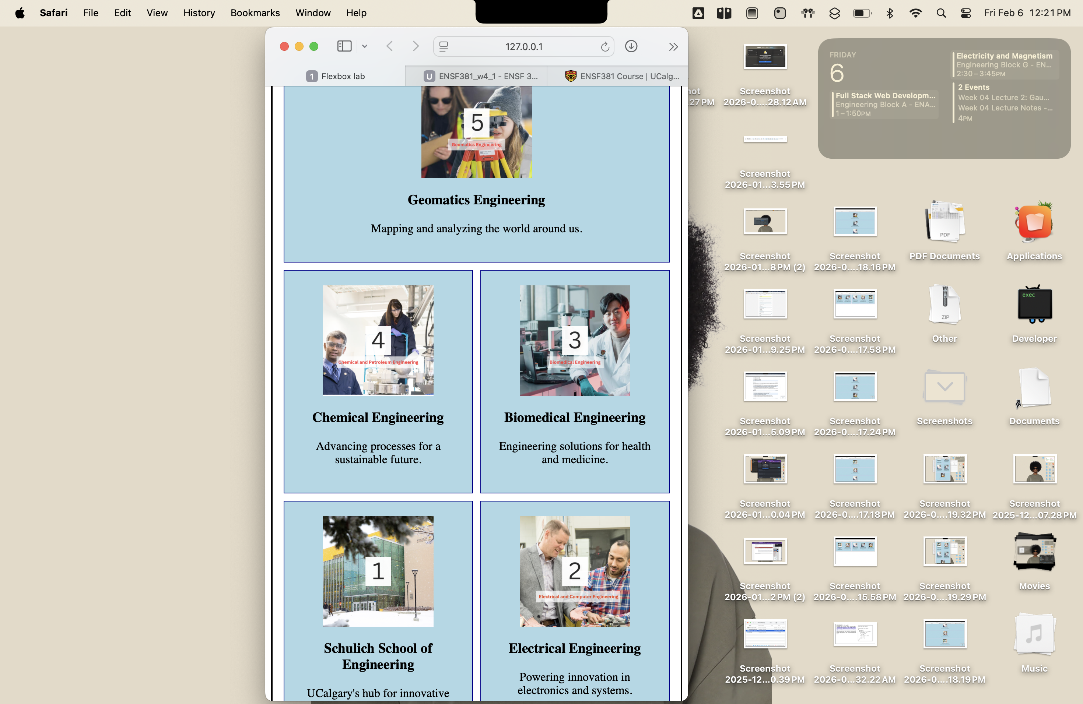

Screenshot from step 16:

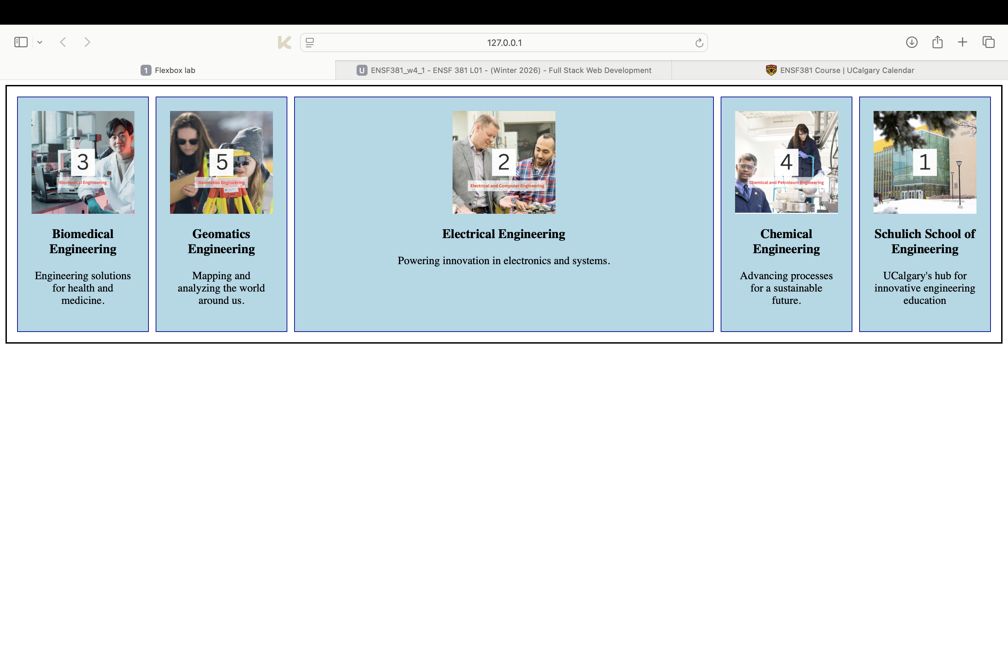

**Exercise 3 Output Screenshot:**

